**Jose Rizal Memorial State University**

**Gov. Guading Adaza St., Sta. Cruz,**

**Dapitan City, Philippines**

**GSU Gateway User Manual**

By:

Bryan Bantillan

Patrick Joshua Nicholas

Edrean Balonga

Bernadette Bantillan

Jenifer Saguindang

May 19, 2025

# **Account Creation**

**Purpose:** This guide walks new users through the process of creating an account to securely access the system.

## *Step 1: Go to Login Page*

1. Open the system login screen.
2. Click on **“Sign Up”** or **“Create Account”**.

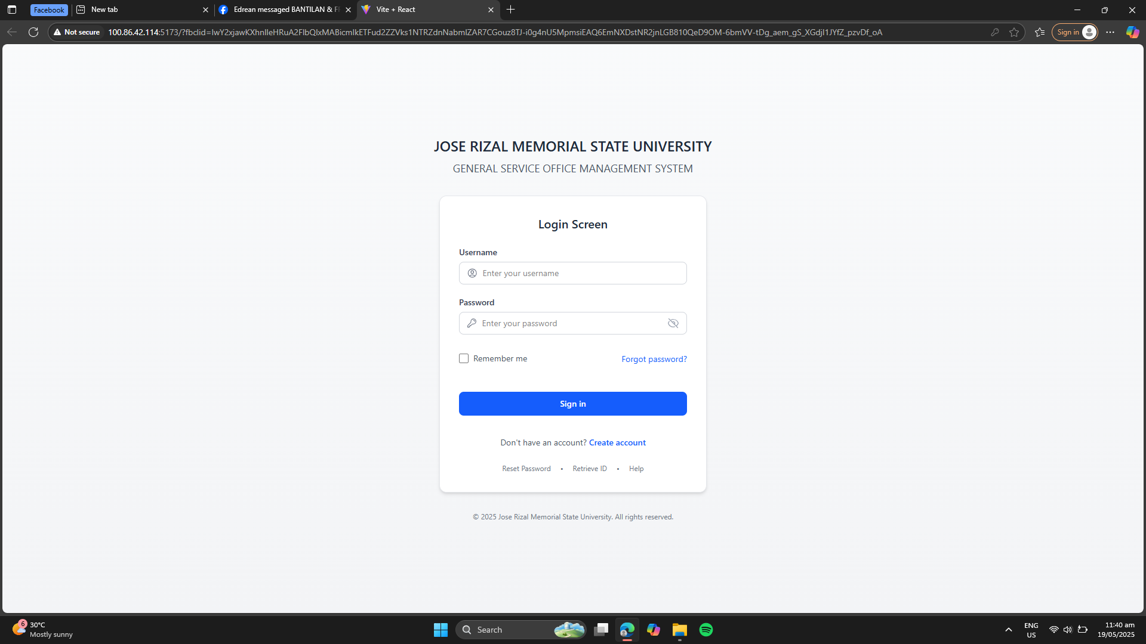

## *Step 2: Fill Out the Registration Form*

1. Enter all the required information in the registration form:
   * Full Name
   * Email Address
   * Password
   * Role (e.g., Student, Faculty, Staff)
   * Department or Office
   * Contact Number
2. 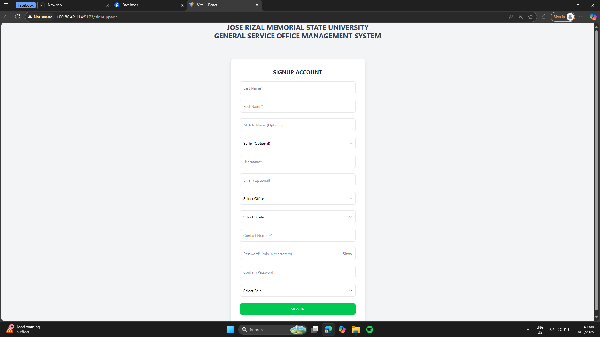Double-check your details for accuracy.

## *Step 3: Submit the Form*

1. Click the **“Signup”** button.
2. You will receive a confirmation message:

**“Your registration has been submitted and is pending admin approval.”**

1. You will then be redirected to the **Login Page**.

**Note:** Wait for an **Admin** to review and approve your account. Once approved, you can log in and begin using the system.

# **Change Password**

**Purpose:** This guide walks new users through the process of changing the password.

## *Step 1: Go to Login Page*

1. Open the system login screen.
2. Log in your credentials.

## *Step 2: Go to Profile*

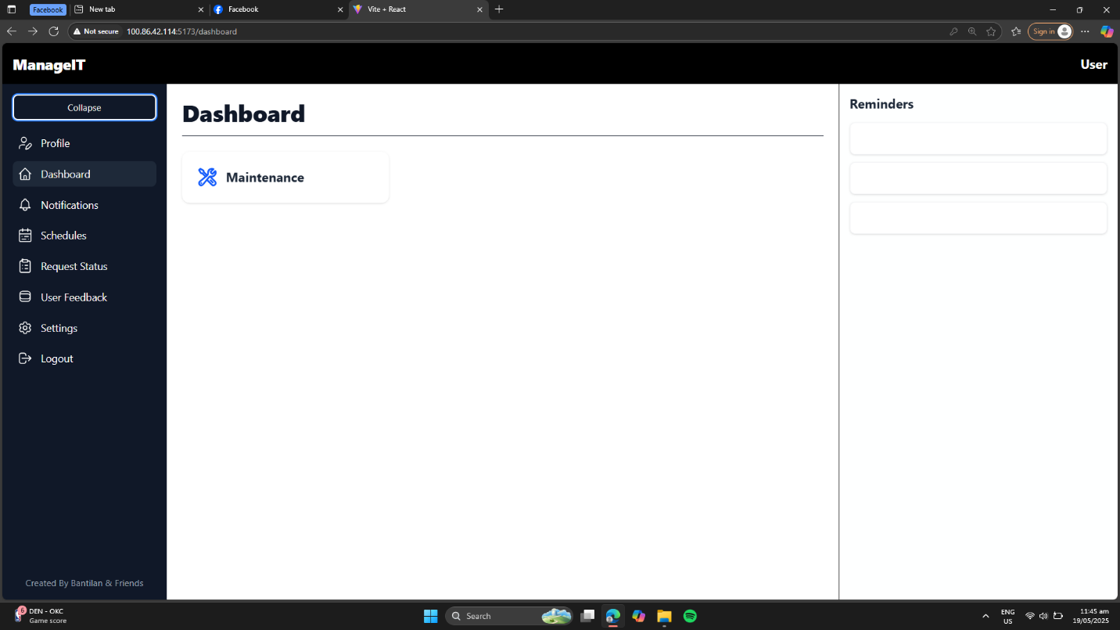

## *Step 3: Click Edit Profile*

## *Step 4: Enter New Password and Save Changes*

# **Maintenance Request Submission**

**Purpose:** This guide helps clients or end users submit maintenance service requests for janitorial, carpentry, electrical, or air conditioning issues.

## *Step 1: Login*

1. Open the maintenance system platform.
2. Log in using your credentials.
   * You can log in as a **Requester**, **Admin**, **Staff**, or **Head.**



## *Step 2: Go to Dashboard*

1. After logging in, you will be directed to your respective **Dashboard**.
2. Click on the **“Maintenance”** option from the navigation menu.

## 

## *Step 3: Select Maintenance Type*

1. Choose the appropriate type of maintenance request:
   * **Janitorial**
   * **Carpentry**
   * **Electrical**
   * 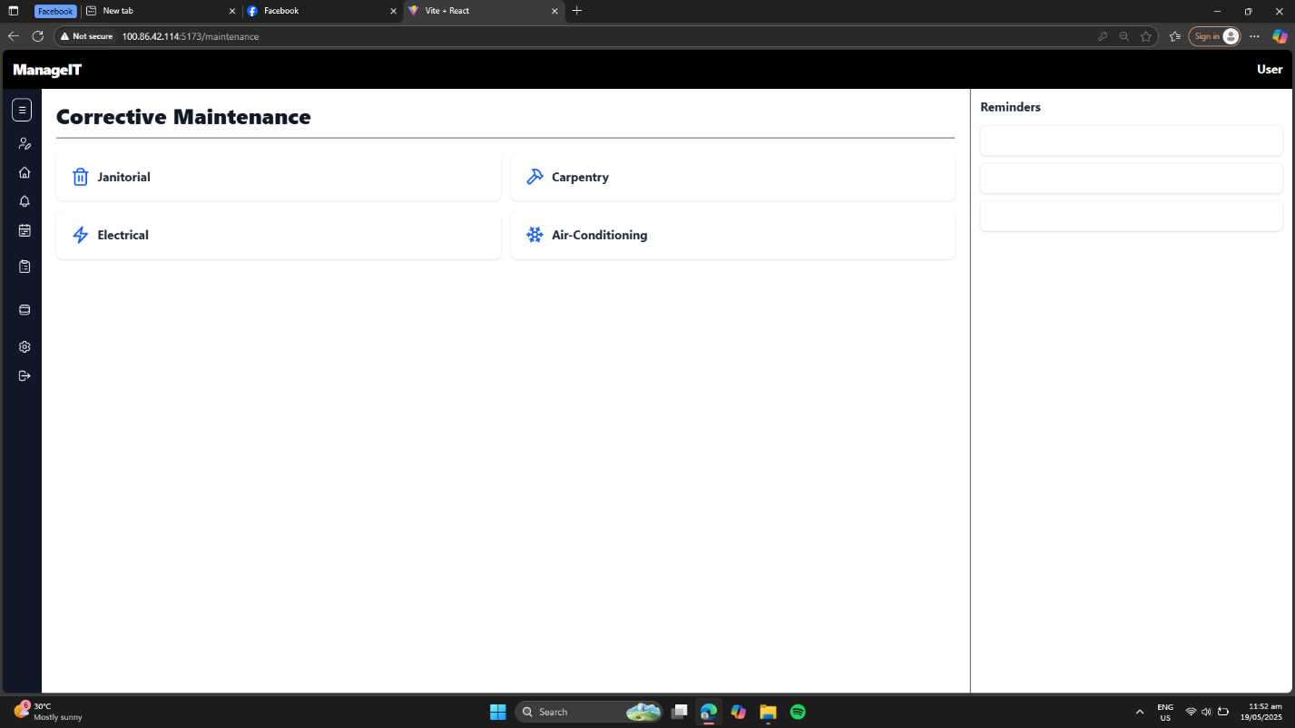**Air Conditioning**

## *Step 4: Fill Out the Request Form*

1. 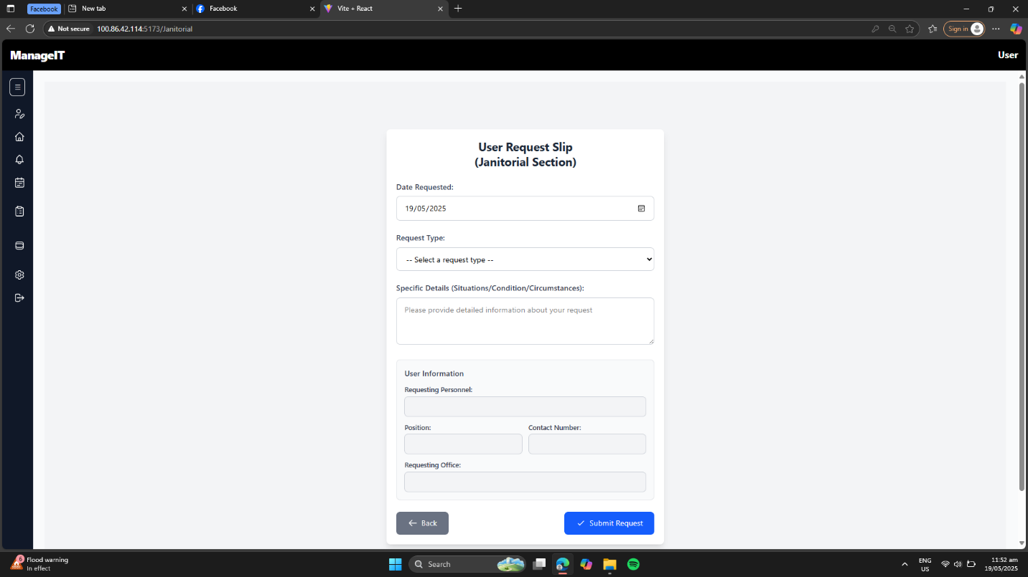Complete all required fields.

## *Step 5: Submit Request*

1. **Review** all entries to ensure accuracy.
2. Click the **“Submit”** button to send the request.

# **Admin-Only Account Approval**

**Purpose:** This guide explains how **Admins** can review and approve or disapprove new user accounts to control system access.

## *Step 1: Login as Admin*

1. Open the system platform.
2. 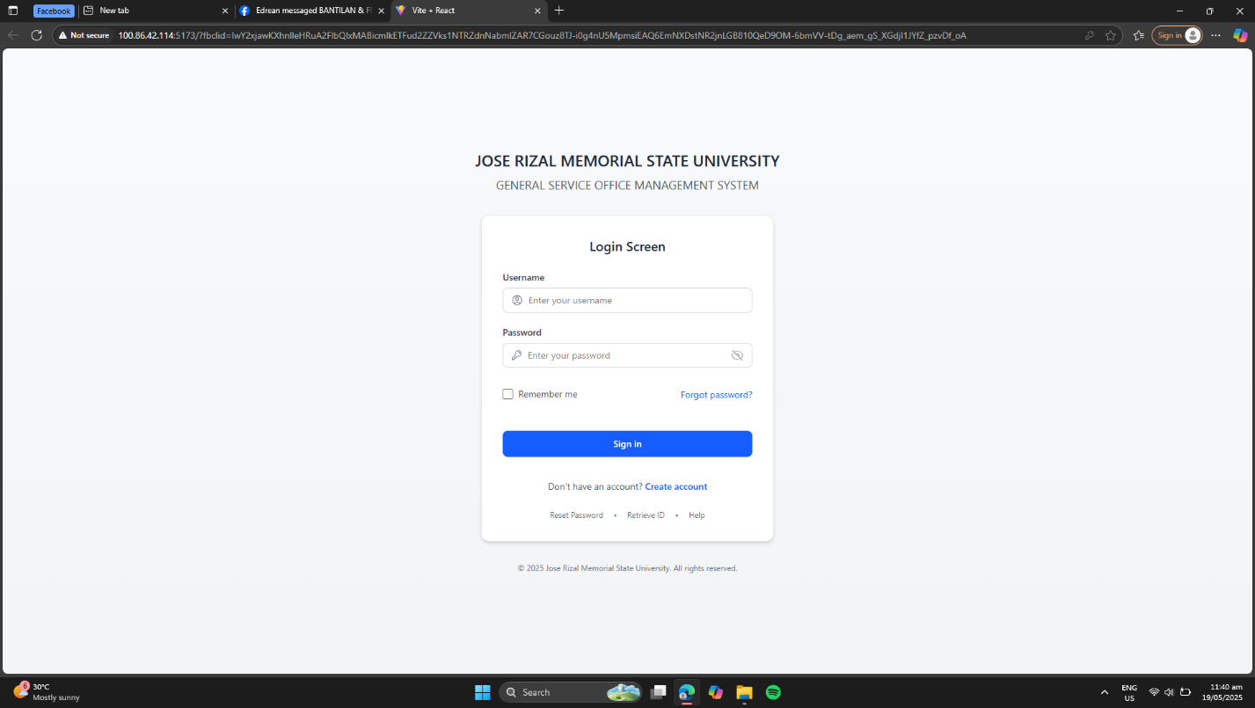Enter your **Admin credentials** to log in.

## *Step 2: Navigate to Admin Dashboard*

1. After logging in, you will land on the **Admin Dashboard**.
2. 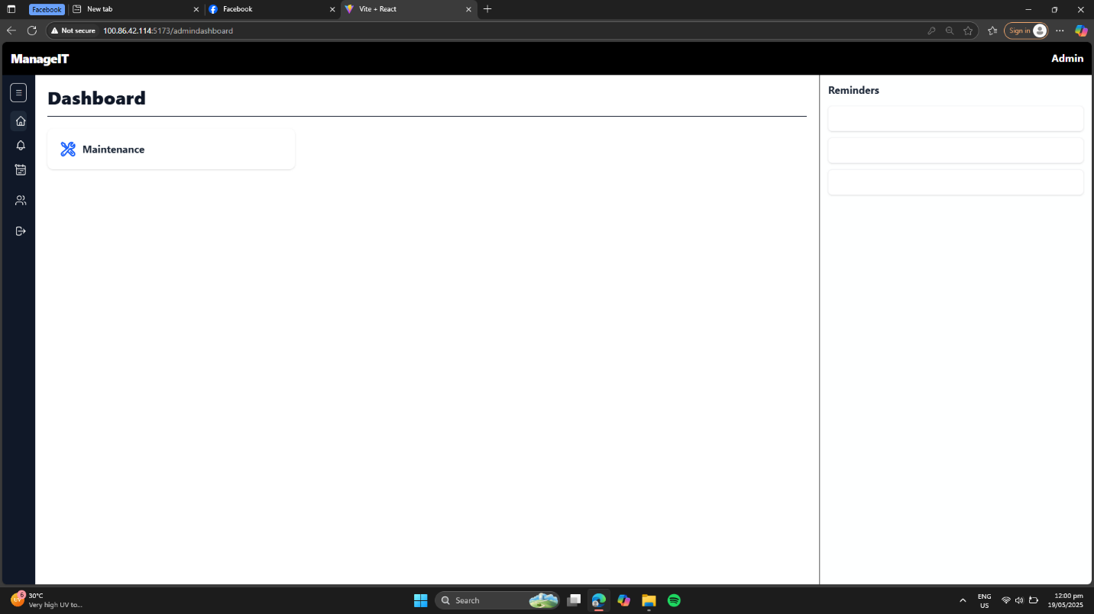Locate and click on **“User Requests”** from the sidebar menu.

## *Step 3: View Pending Requests*

1. In the **User Requests** section, click on the **“Pending”** tab.
2. 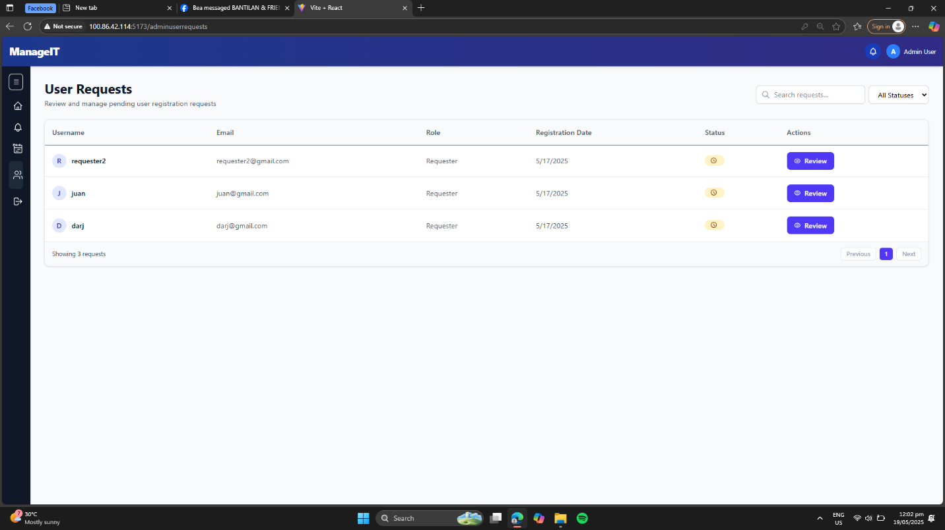A list of all **new user accounts** awaiting approval will be displayed.

## *Step 4: Review User Details*

1. Click on any user entry in the pending list.
2. Review the **full registration information**, including:
   * Role (e.g., Staff, Head)
   * Department or College
   * 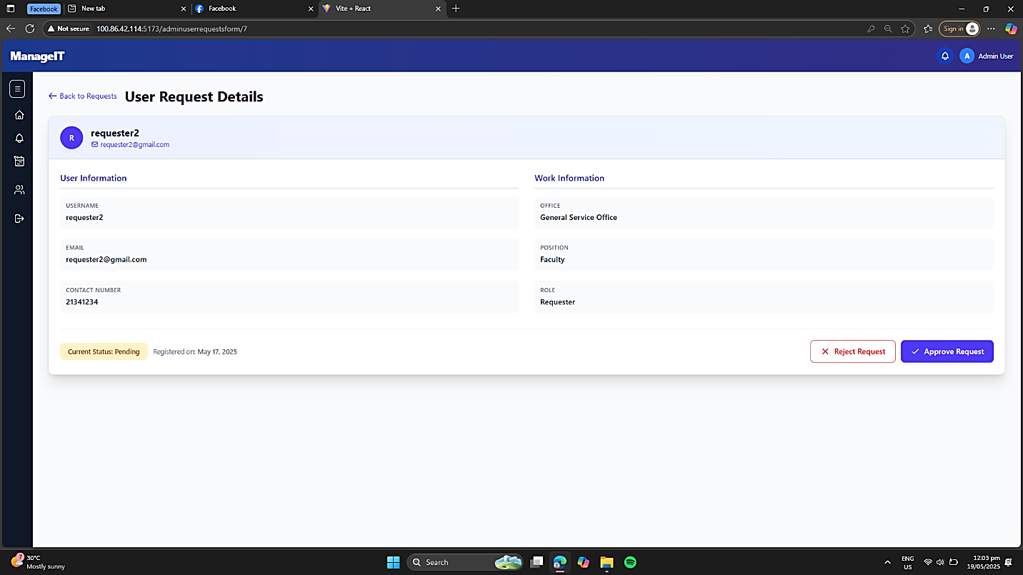Office or Unit

## *Step 5: Take Action*

After reviewing, choose one of the following actions:

| **Action** | **Description** |
| --- | --- |
| **Approve** | Click this to **activate the account** and grant access. |
| **Disapprove** | Click this to **deny access** and reject the account request. |

# **Request Approval for Head & Campus Director**

**Purpose:** This guide enables **Head and Campus Director** users to approve or disapprove maintenance requests submitted by end users.

## *Step 1: Log In*

1. Open the system platform.
2. 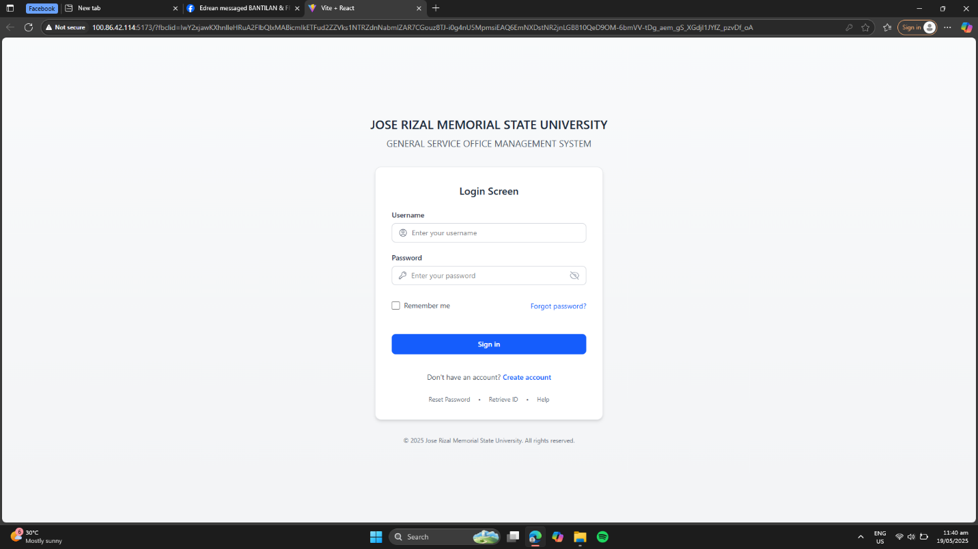Use your **Head or Campus Director** credentials to log in.

## *Step 2: Access the Dashboard*

1. After login, you’ll land on the **Head/CampusDirector Dashboard**.
2. Navigate to the sidebar and click on **“Requests”**.

## *Step 3: Filter Pending Requests*

1. In the **Requests** section, apply a filter to view only those with **“Pending”** status.
2. 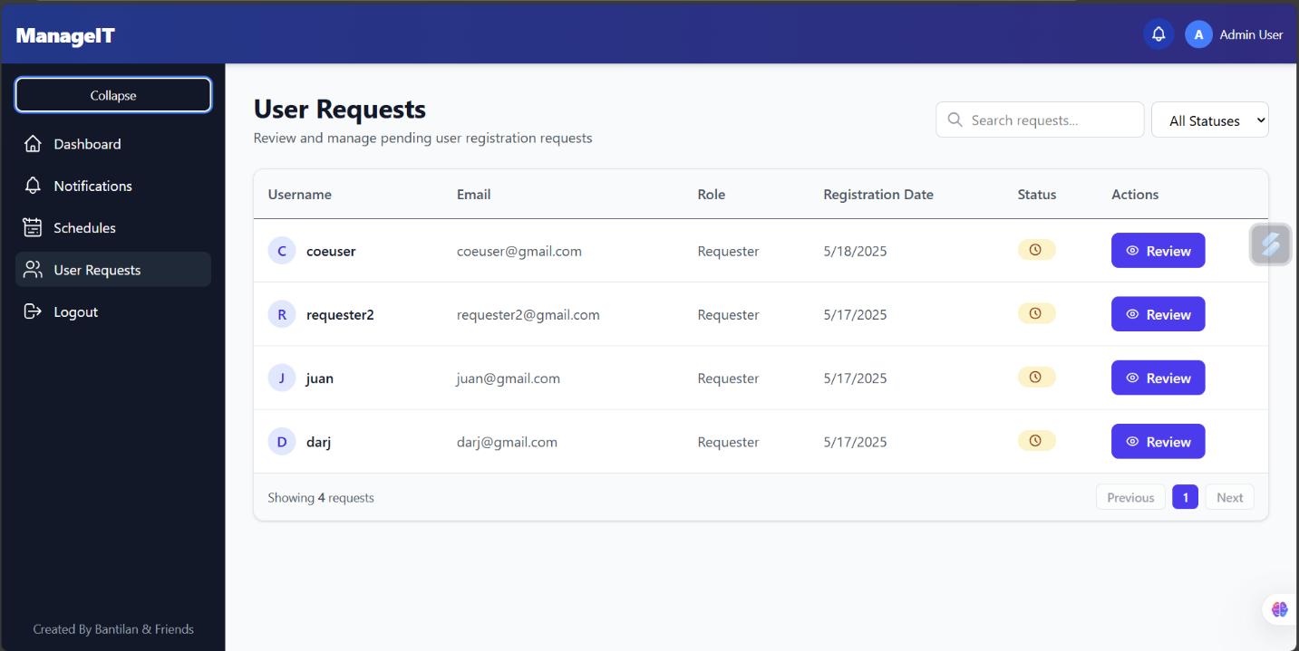This will show a list of user-submitted requests awaiting your review.

## *Step 4: View Request Details*

1. Click the **“Review”** button beside any pending request.
2. The **Request Details Page** will open, showing:
   * Type of Maintenance (e.g., Janitorial, Electrical)
   * Issue Description
   * 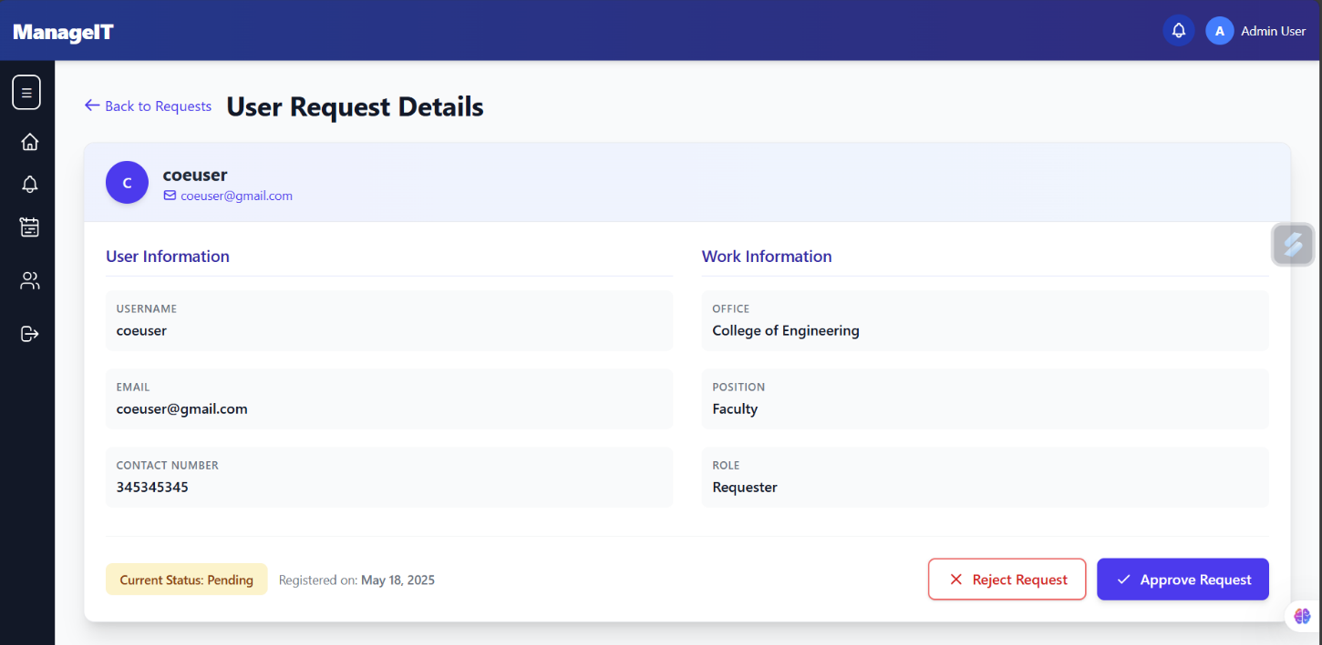Requesting User’s Information

## *Step 5: Take Action*

After reviewing the request, choose from the following action:

| **Action** | **Description** |
| --- | --- |
| **Approve** | Accept and allow the request to proceed. |
| **Disapprove** | Reject the request. You may be prompted to enter a **short comment or reason** for disapproval. |

# **Viewing Pending Requests (Office Staff)**

**Purpose:** This guide allows **Office Staff** to view all **pending user requests**, helping office heads stay informed and manage workload.

## *Step 1: Log In Using Staff Credentials*

1. Open the system platform.
2. 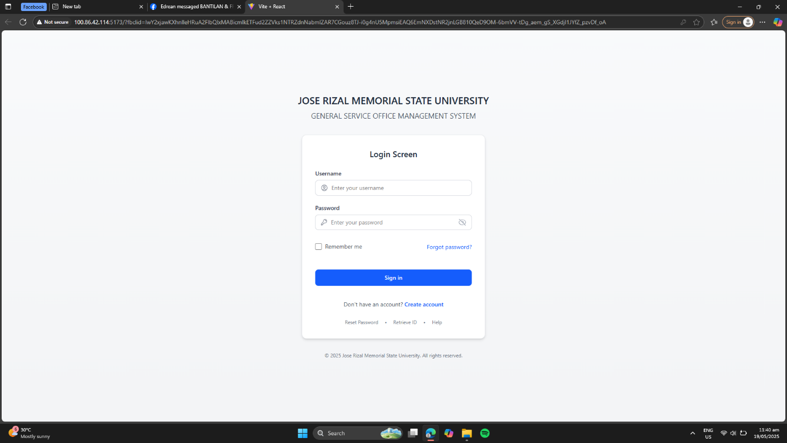Enter your **assigned Office Staff credentials** to log in.

## *Step 2: Access the Staff Dashboard*

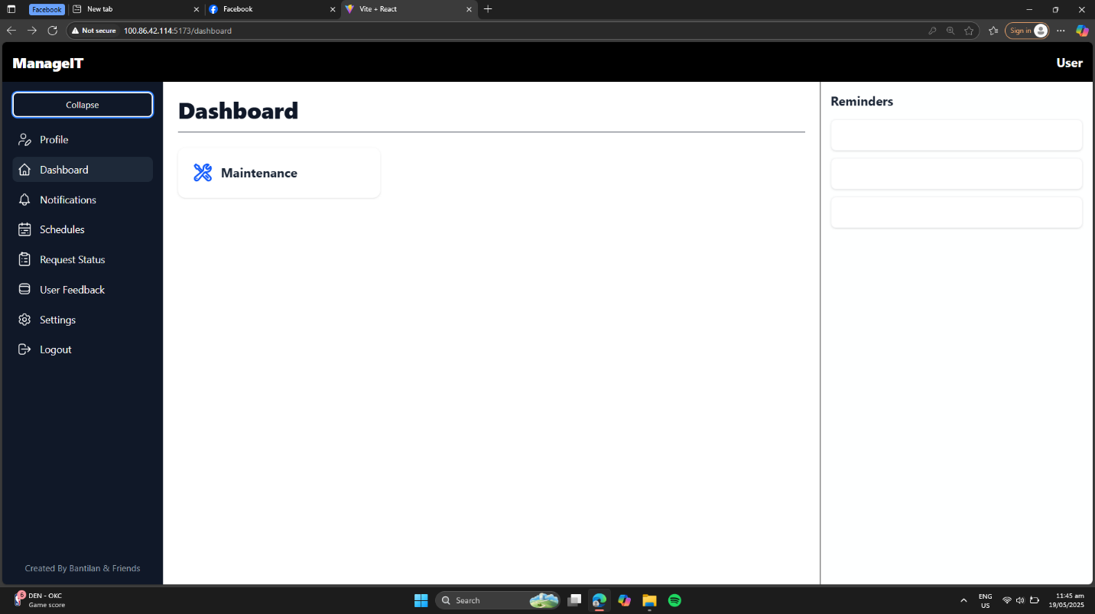After successful login, you will be redirected to the **Staff Dashboard**.

## *Step 3: Navigate to “User Requests”*

1. On the sidebar, click on **“User Requests”**.
2. 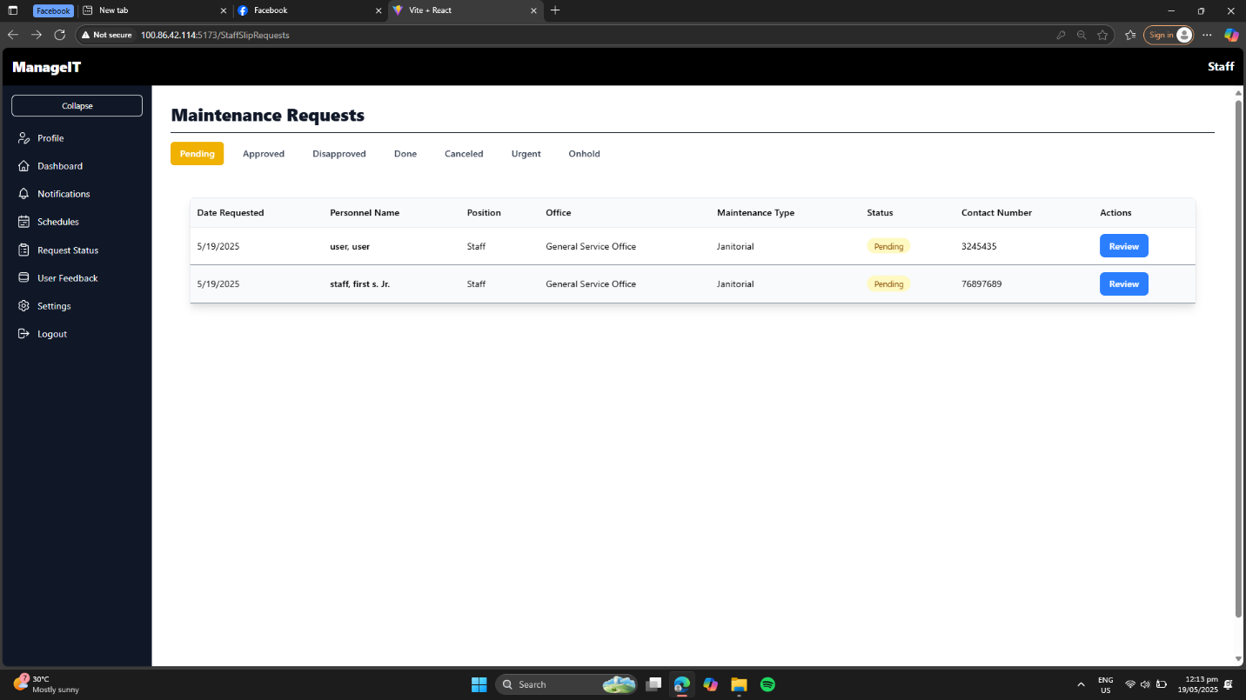This section displays a list of all user-submitted requests.

## *Step 4: Browse the List of Pending Requests*

* The list will automatically show **pending requests**
* 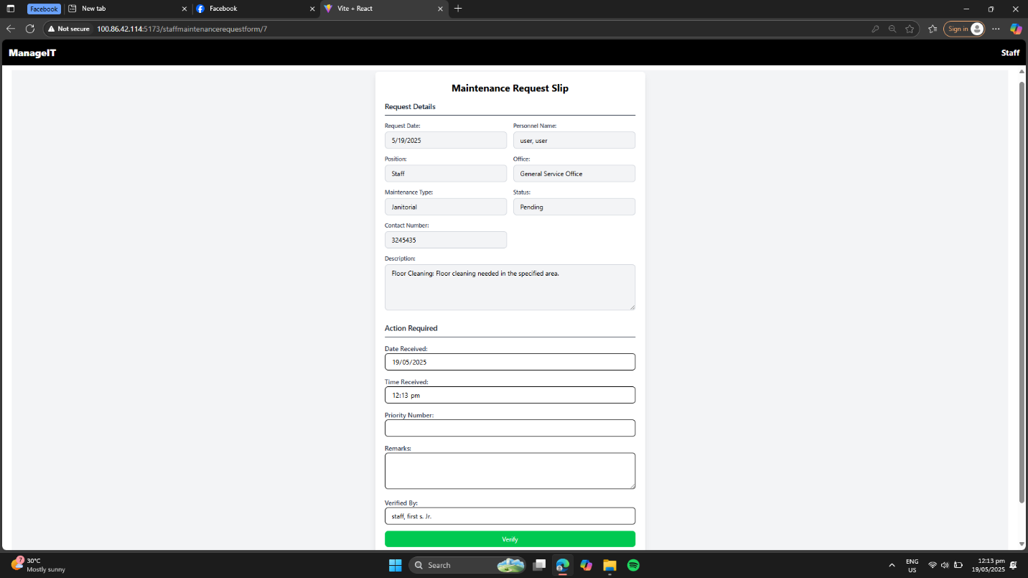You can scroll through and monitor the request details (e.g., request type, requestor name, submission date).

Note: Office Staff can ***view*** pending requests but cannot take approval actions.